Tanana Valley Watershed Association
2013 Annual Report of Piledriver Slough
Stream Activities

In fulfillment of Mitigation Measure 56 of the Service Transportation Board Which states: “Prior to construction of Salcha Alternative Segment 1, ARRC shall develop appropriate mitigation in consultation with ADF&G to prevent blockage of Piledriver and Twenty-three mile Sloughs by beaver dams (as a result of flushing flows caused by ARRC-proposed channel plugs). Mitigation may include monitoring conducted by ARRC at a frequency agreed to by ADF&G.”
Tanana Valley Watershed Association (TVWA) in consultation with The Alaska Department of Fish and Game (AKDFG) through a Memorandum of Agreement implemented fish monitoring within the Piledriver Slough in the city of Salcha, and 23 Mile Slough. TVWA will manage this program through 2022 and submit an annual report to AKDF&G, the Alaska Rail Road (AKRR) outlining tasks and accomplishments achieved during the past year. Full detailed report is available at AGF&F division of habitat.
Scope of Work:
- 23 Mile Slough located at mile 4.5 of Farmers Loop Rd was sampled twice in the summer May 23rd and fall August 27th.
- Sampling was conducted on the upper Piledriver section three times, summer June 10th, fall September 6th, and after beaver dam removal on September 24th. The lower section was sampled twice in Summer June 14th and fall August 30th.
- The section of Piledriver Slough from the levee site to the Baily Bridge was surveyed to find dams twice during both spring and fall.
- Fish distribution, size and species type were recorded.
The Piledriver Slough Mitigation Plan was created to assess impacts of the Northern Rail Extension Project-Phase 1. Due to construction of the new rail extension a levee was put in place that blocks flushing flows into the Piledriver Slough from the Tanana River. The flow-rate changes may cause ice and log jams that would hinder fish passage as well as beaver dams, which will no longer be naturally knocked out by flushing spring flows.
Reporting:
The Piledriver project consists of monitoring and reporting over ten years (2012-2022) any changes that the Piledriver slough may experience. Several aspects of the report will include:
- Beaver dam activity
- Riparian Changes
- Invasive Species of Concern
- Hydrology Monitoring
- Fish Monitoring
Beaver Dam activity was surveyed during the summer and fall; all locations of activity were marked with a GPS location. Beaver dam activity was classified as active or inactive and labeled as a dam, secondary dam or lodge see Attachment A: Piledriver Slough Beaver Activity Survey Report 2013. Riparian changes were recorded through a habitat assessment. No Invasive species of concern were observed. 2013 was a bi-year for hydrology monitoring. TVWA will be reinstalling the hydrology monitor in the spring of 2014. Alaska Department of Fish and Game issued TVWA a Fish Resource Permit that can be viewed in Attachment B: Fish Resource Permit and Attachment C: Fish Resource Permit Amendment #1. Once sampling was completed TVWA submitted the annual collection of data report on fish species, type, size and location. The collections report can be viewed in Attachment D: Collection of Data Report. TVWA will continue to promote this project at various events throughout the Tanana Valley. A formal PowerPoint Presentation is included in Attachment E: Piledriver Slough Project 2013.
Implementation of the project is achieved in three parts, all with the use of minnow traps baited with salmon roe. Part One: 23 Mile Slough was surveyed and sampled by TVWA staff. All fish species seen in the water or caught in minnow traps were reported. Part two: the lower five miles of Piledriver slough was sampled by TVWA staff via canoe. TVWA report all beaver activity seen while setting and checking minnow traps to monitor fish species, location and size. Part three: the upper five miles of Piledriver Sough, monitored with cooperation from the students and staff of Salcha Elementary School. This project enabled children to connect with nature, learn hands on science and become stewards within their community. TVWA has created youth education in the fields of habitat, invasive species, fish species monitoring, beaver education and water quality as well as incorporating healthy streams healthy bugs from the U.S. Department Fish and Wildlife Fairbanks field office.
Piledriver Slough was found to have a significant drop in fish caught in minnow traps in 2013. A total of 24 fish were captured and released at 6 locations, 16 locations were sampled, which are all listed in Attachment A. Of the fish caught there were four different species, Arctic Grayling, Lake Chub, Burbot, and Slimy Sculpin. In 2012, 101 fish were caught, with only 24 caught in 2013, a total reduction of 75 percent. Within the upper section of Piledriver slough one Slimy Sculpin was caught on September 6th and one caught on September 24th. No fish were seen in the water in upper Piledriver. In 2012 49 fish were caught in upper Piledriver, leaving a reduction in fish caught of 96 percent. The Lower section of Piledriver Sough was sampled during known spawning seasons to establish a better count of fish in the water. No fish were seen in the water above the largest beaver dam located at site G. A total of 22 fish were caught in minnow traps in 2013, while 52 were caught in 2012 a reduction of 60 percent. In the summer sampling approximately 110 adult Arctic Grayling were spotted in the water starting below site G and ending at site K. In the fall sampling approximately 600 plus Arctic Graying were spotted in the water 75 percent of those seen were between one and three inches long. 103 spawned out Chum Salmon were seen in the water and 22 live Chum Salmon. In 2013, 23 Mile Slough was sampled for the first time. A total of three fish were caught at two locations in minnow traps. Arctic Grayling were seen under a bridge at (64.65617, -147.17145).

Successful implementation of the Piledriver Sough Project 2013 includes the following activities:
- TVWA hosted a training day at the Salcha Elementary School held on June 9th. Presentation for staff and students included water safety, fish ID, fish handling, water quality, invasive species, and habitat assessment. A second training day was held for the entire Elementary School on September 5th the beginning of a new school year. The training refreshed experienced students and staff while introducing the project components to new attendees and volunteers.
- TVWA’s youth science education curriculum connects nature and education in an outdoor setting. The curriculum included how to conduct water quality, fish identification, habitat assessment, and healthy bugs. New beaver education curriculum was added in 2013 to teach the youth about how beavers live, the environments they create and how it impacts the stream. Each child was equipped with a tool kit containing supplies and safety gear to be a true scientist in the field.
- Due to a late breakup May (spring) sampling was not conducted. Ice was still on the edges of the slough when the first sampling was conducted in June. Sampling took place in summer, and fall. All equipment was inventoried, cleaned, and serviced before and after the sampling season.
- As part of our project outreach a presentation was on display for community awareness during the 2013 Riverwalk event held on June 8th.
- TVWA attended several outreach events in 2013 to include, Chena River Summit held on May 1st, Earth Day Fair on April 22nd, TVWA’s Open house on April 22nd. A display provided information to the public that outlined the full scope of the Piledriver Project and highlighted the Salcha Elementary School children’s stewardship accomplishments.
- The Piledriver project maintained strong community involvement: 14 members of the Salcha Elementary School staff, 20 community and parent volunteers, 77 children attending Salcha Elementary School, TVWA staff, the Department of Fish and Game, U.S. Department of Fish and Wildlife, Fairbanks Soil and Water Conservation District, Eielson Natural Resources, Kewtt and HDR participated and contributed to the Piledriver Projects success.
- The Salcha Elementary School’s Kindergarten and First Grade class won a blue ribbon at the Fairbanks North Star Borough’s District Science Fair for a presentation given about their scientific studies on the Piledriver slough. The Museum of the North gave special recognition to the class and presented them with a microscope.

Attachment A:
Piledriver Slough Beaver Activity Survey Report 2013
Tanana Valley Watershed Association
November 14, 2013
The Piledriver slough mitigation plan monitors changes to the Piledriver slough that may be caused by beaver activity. Due to construction of the new rail extension a levee was put in place that blocks flushing flows into the Piledriver Slough from the Tanana River. The flow-rate changes may cause ice and log jams that would hinder fish passage. Beaver dams may no longer be knocked out by flushing spring flows and could cause further fish passage issues. Beavers are a very natural part of the local environment and can help or hinder the other wildlife in the area. In the case of Piledriver Slough monitoring will be conducted to evaluate the beaver dams and determine if they need to be removed to aid fish passage through the slough.
The ten mile section of Piledriver from the levee site to the Bailey Bridge was monitored on June 10th and 14th, August 30th and September 6th by the Tanana Valley Watershed Association (TVWA). Identification of dam, and lodges were marked with GPS Locations. Pictures and videos were taken for further comparison and review. Fish monitoring was conducted at 18 sites, with a total of 101 fish caught and released. Beaver dam activity was classified as active or inactive and labeled as a dam, secondary dam and lodge.
A total of seven beaver dams were surveyed, identifying sites A and G as primary dams. The largest dam of concern was at site G. It was recommend in 2012 that site G be breached in the spring to allow for fish passage. Follow up with site A in the spring to determine if a breach is needed. The Dam at site H is considered a secondary dam, it is large but has passable flow through it. It is recommended that site H be monitored and determined if a breach is needed in the spring. Sites B, C, I and J were all active secondary dams with little concern for fish passage. Dam J appeared to be an old dam with full water flow around it. All dams can be referenced below on page two. Dams of concern should be breached to allow fish passage each year at the end of the open water season, and at midsummer if necessary. Three largest dams can be viewed in Figure 1.
Following the recommendation given by TVWA in 2012, Kewtt and HDR with the supervision on TVWA staff removed the primary dam at site G on September 10th. The dam at site G was approximately four feet tall and stretched from one side of the bank to the other, Figure 2. No fish were seen and only two were caught above this dam site in 2013. Using hand tools the crew was able to remove a significant portion of the dam to allow for fish passage, Figure 3. TVWA staff surveyed the dam on September 24th to see if the beaver was rebuilding before ice over. There was no new beaver activity at this site, and there was a five foot opening that allowed for fish passage.

Dam Reference:
Site A: Beaver dam active possible primary dam. Recommended review in the spring and possible breach needed for fish passage.
N 64.58597 W 147.06924
Site B: Beaver Dam active Split braded area, flowing open areas, blocked in June and open fully in September, secondary dam.
N 64.58698 W 147.07030
Site C: Beaver dam about 4 feet across from 2012 was not present in 2013.
64.88828 W 147.07118
Site D: Beaver lodge very active deep pools.
N 64.59647 W 147.08452
Site E: Beaver Lodge abandoned, no new activity in 2013. Had activity in 2012
N 64.60268 W 147.08339
Site F: Very active beaver lodge, deep pools.
N 64.60268 W 147.08339
Site G: Full beaver dam across the water, primary dam. Large trees in use felled. Dam height of 4 ½ feet, breached on September 10th, monitored again on September 24th.
N64.60328 W 147.08560
Site H: Full beaver dam with a small opening about 2 ½ 3 feet wide. Spawned out adult chum salmon, on and around the dam, area had very strong fish odor. Secondary dam.
N 64.60441 W 147.08794
Site I: Partial dam, sporadic, like it may have been broken up some. More spawned out chum salmon on dam, very strong fish odors. Secondary Dam.
N64.60561 W147.08676
Site J: Old beaver dam with major silt build up. No new activity seen.
N 64.60847 W 147.08932
Site K: Old beaver lodge no new activity seen
N64.61459 W147.08888
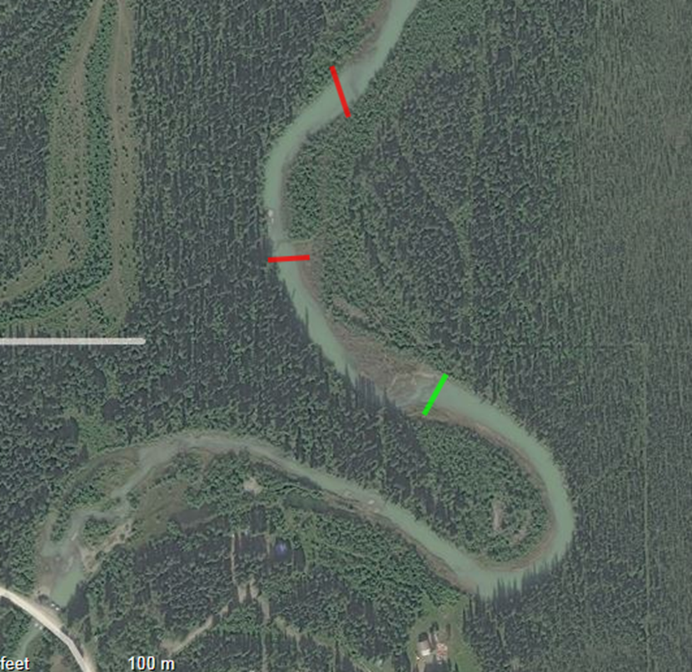
Figure 1. Dam one in Green site G (N64.60328 W-147.08560) was removed on Tuesday the 10th of September 2013. Dams two site H (N 64.60441 W -147.08794) and three site I (N64.60561 W-147.08676) in red had flowing openings for fish passage but were also very large.
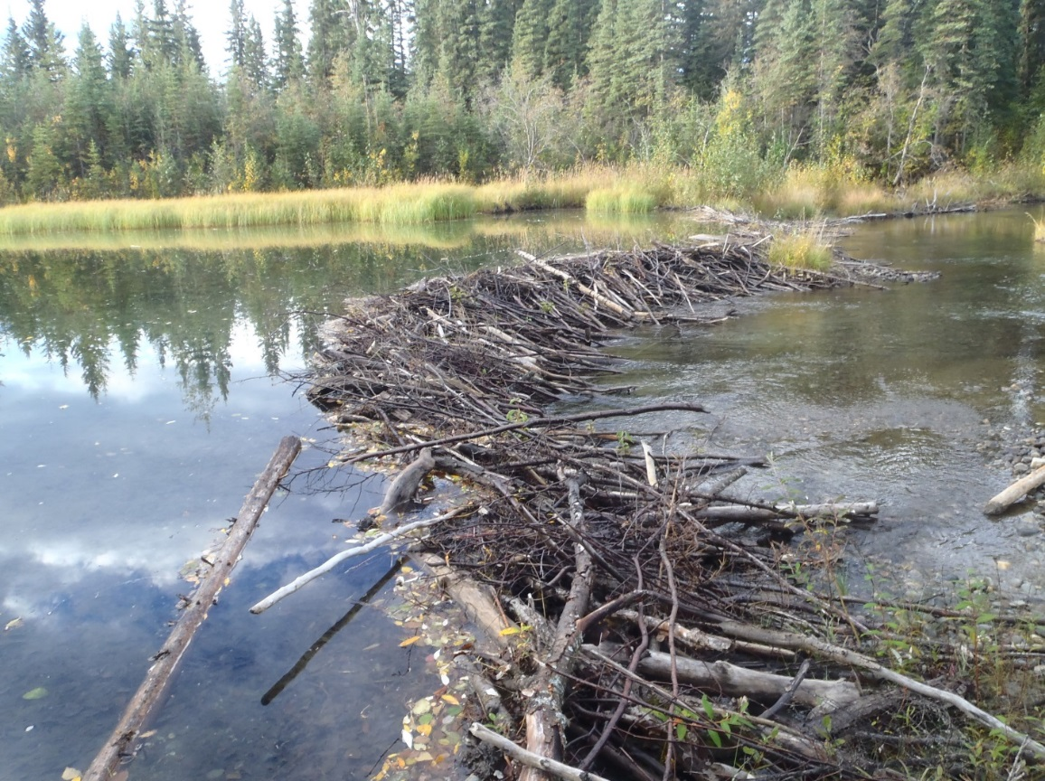
Figure 2 Beaver dam at site G before dam removal.

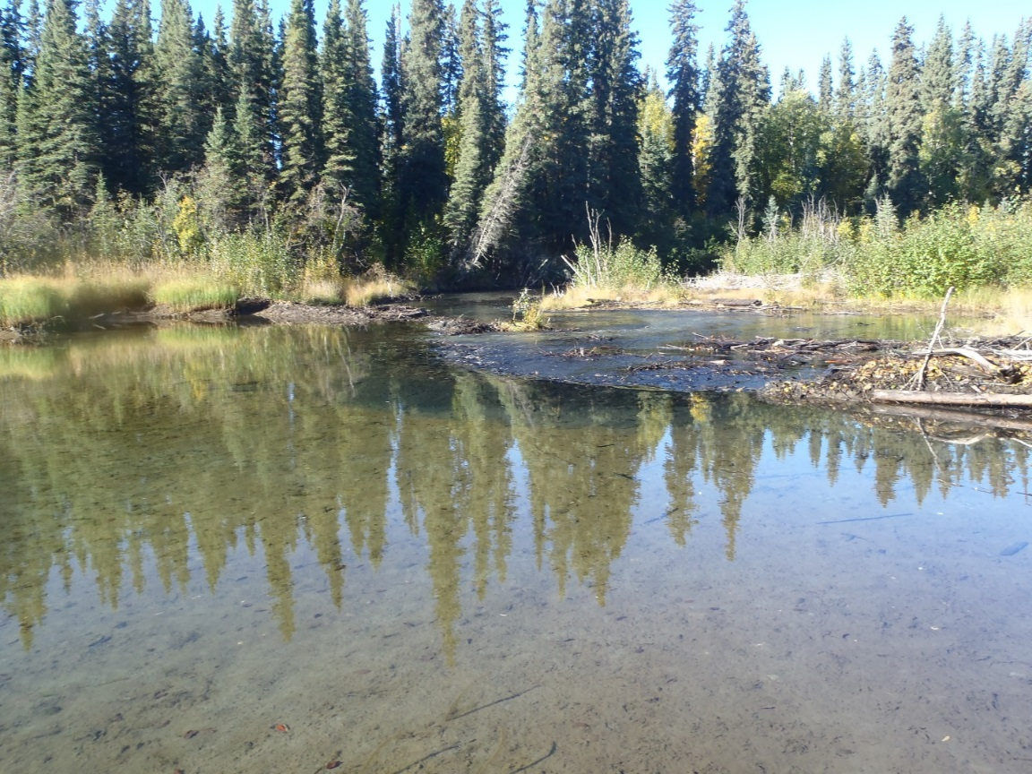
Figure 3 Beaver Dam at site G after dam removal.

